**A**

***PROJECT REPORT***

*on*

**DIGIPAY - A digital wallet integrated with e-Rupi**

*Submitted in partial fulfilment of the requirements for the degree of*

**BACHELOR OF TECHNOLOGY**



Session: 2024

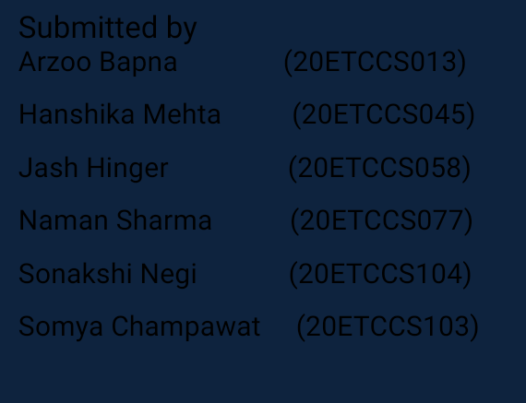



**A**

***PROJECT REPORT***

*Submitted in partial fulfilment of the requirements for the degree of*

**BACHELOR OF TECHNOLOGY**



**Session: 2024**

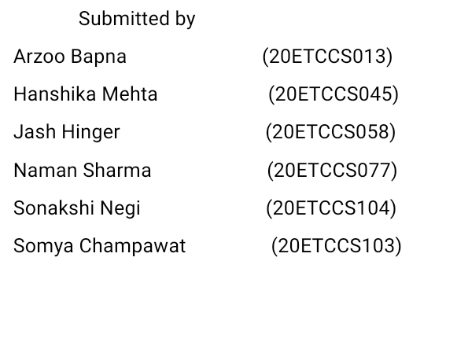

Submitted by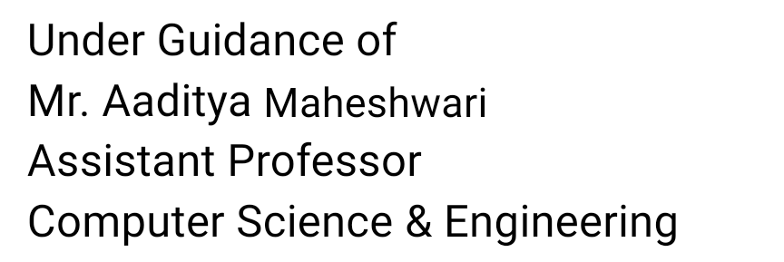





Department of Computer Science and Engineering

Techno India NJR Institute of Technology, Udaipur-313001

**Certificate**

This is to certify that project work titled **DIGIPAY** by Arzoo Bapna was successfully carried out in the Department of Computer Science and Engineering, TINJRIT and the report is approved for submission in the partial fulfilment of the requirements for award of degree of Bachelor of Technology in Computer Science and Engineering.

Mr. Aaditya Maheshwari Dr. Rimpy Bishnoi

Assistant Professor Professor and HOD

Computer Science and Engineering Dept. of CSE TINJRIT, Udaipur

Date Date



Department of Computer Science and Engineering

Techno India NJR Institute of Technology, Udaipur-313001

**Certificate**

This is to certify that project work titled **DIGIPAY** by Hanshika Mehta was successfully carried out in the Department of Computer Science and Engineering, TINJRIT and the report is approved for submission in the partial fulfilment of the requirements for award of degree of Bachelor of Technology in Computer Science and Engineering.

Mr. Aaditya Maheshwari Dr. Rimpy Bishnoi

Assistant Professor Professor and HOD

Computer Science and Engineering Dept. of CSE TINJRIT, Udaipur

Date Date



Department of Computer Science and Engineering

Techno India NJR Institute of Technology, Udaipur-313001

**Certificate**

This is to certify that project work titled **DIGIPAY** by Jash Hinger was successfully carried out in the Department of Computer Science and Engineering, TINJRIT and the report is approved for submission in the partial fulfilment of the requirements for award of degree of Bachelor of Technology in Computer Science and Engineering.

Mr. Aaditya Maheshwari Dr. Rimpy Bishnoi

Assistant Professor Professor and HOD

Computer Science and Engineering Dept. of CSE TINJRIT, Udaipur

Date Date



Department of Computer Science and Engineering

Techno India NJR Institute of Technology, Udaipur-313001

**Certificate**

This is to certify that project work titled **DIGIPAY** by Naman Sharma was successfully carried out in the Department of Computer Science and Engineering, TINJRIT and the report is approved for submission in the partial fulfilment of the requirements for award of degree of Bachelor of Technology in Computer Science and Engineering.

Mr. Aaditya Maheshwari Dr. Rimpy Bishnoi

Assistant Professor Professor and HOD

Computer Science and Engineering Dept. of CSE TINJRIT, Udaipur

Date Date



Department of Computer Science and Engineering

Techno India NJR Institute of Technology, Udaipur-313001

**Certificate**

This is to certify that project work titled **DIGIPAY** by Sonakshi Negi was successfully carried out in the Department of Computer Science and Engineering, TINJRIT and the report is approved for submission in the partial fulfilment of the requirements for award of degree of Bachelor of Technology in Computer Science and Engineering.

Mr. Aaditya Maheshwari Dr. Rimpy Bishnoi

Assistant Professor Professor and HOD

Computer Science and Engineering Dept. of CSE TINJRIT, Udaipur

Date Date



Department of Computer Science and Engineering

Techno India NJR Institute of Technology, Udaipur-313001

**Certificate**

This is to certify that project work titled **DIGIPAY** by Somya Champawat was successfully carried out in the Department of Computer Science and Engineering, TINJRIT and the report is approved for submission in the partial fulfilment of the requirements for award of degree of Bachelor of Technology in Computer Science and Engineering.

Mr. Aaditya Maheshwari Dr. Rimpy Bishnoi

Assistant Professor Professor and HOD

Computer Science and Engineering Dept. of CSE TINJRIT, Udaipur

Date Date



Department of Computer Science and Engineering

Techno India NJR Institute of Technology, Udaipur-313001

**Examiner Certificate**

This is to certify that the following student **Arzoo Bapna** of final year B.Tech. (Computer Science and Engineering), was examined for the project work titled

***DIGPAY -* A digital wallet integrated with e-Rupi**

during the academic year 2023 – 2024 at Techno India NJR Institute of Technology, Udaipur

**Remarks:**

**Date:**

Signature Signature

(**Internal Examiner**) (**External Examiner**)

Name :- Name :-

Designation:- Designation:-

Department: - Department: -

Organization:- Organization:-



Department of Computer Science and Engineering

Techno India NJR Institute of Technology, Udaipur-313001

**Examiner Certificate**

This is to certify that the following student **Hanshika Mehta** of final year B.Tech. (Computer Science and Engineering), was examined for the project work titled

***DIGPAY -* A digital wallet integrated with e-Rupi**

during the academic year 2023 – 2024 at Techno India NJR Institute of Technology, Udaipur

**Remarks:**

**Date:**

Signature Signature

(**Internal Examiner**) (**External Examiner**)

Name :- Name :-

Designation:- Designation:-

Department: - Department: -

Organization:- Organization:-



Department of Computer Science and Engineering

Techno India NJR Institute of Technology, Udaipur-313001

**Examiner Certificate**

This is to certify that the following student **Jash Hinger** of final year B.Tech. (Computer Science and Engineering), was examined for the project work titled

***DIGPAY -* A digital wallet integrated with e-Rupi**

during the academic year 2023– 2024 at Techno India NJR Institute of Technology, Udaipur

**Remarks:**

**Date:**

Signature Signature

(**Internal Examiner**) (**External Examiner**)

Name :- Name :-

Designation:- Designation:-

Department: - Department: -

Organization:- Organization:-



Department of Computer Science and Engineering

Techno India NJR Institute of Technology, Udaipur-313001

**Examiner Certificate**

This is to certify that the following student **Naman Sharma** of final year B.Tech. (Computer Science and Engineering), was examined for the project work titled

***DIGPAY -* A digital wallet integrated with e-Rupi**

during the academic year 2023 – 2024 at Techno India NJR Institute of Technology, Udaipur

**Remarks:**

**Date:**

Signature Signature

(**Internal Examiner**) (**External Examiner**)

Name :- Name :-

Designation:- Designation:-

Department: - Department: -

Organization:- Organization:-



Department of Computer Science and Engineering

Techno India NJR Institute of Technology, Udaipur-313001

**Examiner Certificate**

This is to certify that the following student **Sonakshi Negi** of final year B.Tech. (Computer Science and Engineering), was examined for the project work titled

***DIGPAY -* A digital wallet integrated with e-Rupi**

during the academic year 2023 – 2024 at Techno India NJR Institute of Technology, Udaipur

**Remarks:**

**Date:**

Signature Signature

(**Internal Examiner**) (**External Examiner**)

Name :- Name :-

Designation:- Designation:-

Department: - Department: -

Organization:- Organization:-



Department of Computer Science and Engineering

Techno India NJR Institute of Technology, Udaipur-313001

**Examiner Certificate**

This is to certify that the following student **Somya Champawat** of final year B.Tech. (Computer Science and Engineering), was examined for the project work titled

***DIGPAY -* A digital wallet integrated with e-Rupi**

during the academic year 2023 – 2024 at Techno India NJR Institute of Technology, Udaipur

**Remarks:**

**Date:**

Signature Signature

(**Internal Examiner**) (**External Examiner**)

Name :- Name :-

Designation:- Designation:-

Department: - Department: -

Organization:- Organization:-

**Preface**

This project report documents the digitalization of E-rupi vouchers, aimed at streamlining the process of distributing and redeeming vouchers for farmers and individuals in need. The initiative seeks to leverage modern technology to enhance accessibility and efficiency in obtaining agricultural resources such as fertilizers, seeds, and tools.

The idea stemmed from the need to modernize the traditional voucher distribution system, which often faced challenges such as manual processing, delays, and inconsistencies. By transitioning to a digital platform, we aimed to overcome these hurdles and create a seamless experience for both voucher recipients and merchant stores.

Throughout this report, we delve into the various aspects of the project, including its objectives, technological implementation, system design, testing procedures, and outcomes. We also reflect on the challenges encountered during the journey and outline potential avenues for future enhancements.

This project represents a collaborative effort involving individuals passionate about leveraging technology for social good. We extend our gratitude to all those who contributed their time, expertise, and support to make this endeavor a reality.

We hope that this report serves as a comprehensive resource for understanding the digitalization of E-rupi vouchers and inspires further innovations in the realm of agricultural assistance.

Department of Computer Science and Engineering

Techno India NJR Institute of Technology, Udaipur-313001

**ACKNOWLEDGMENT**

We take this opportunity to record our sincere thanks to all who helped us to successfully complete this work. Firstly, we are grateful to our **supervisor Mr. Aaditya Maheshwari** for his invaluable guidance and constant encouragement, support and most importantly for giving us the opportunity to carry out this work.

We would like to express our deepest sense of gratitude and humble regards to

our **Head of Department Dr. Rimpy Bishnoi** for giving invariable encouragement in our endeavors and providing necessary facility for the same. Also, a sincere thanks to all faculty members of CSE, TINJRIT for their help in the project directly or indirectly.

Finally, we would like to thank my friends for their support and discussions that have proved very valuable for us. We are indebted to our parents for providing constant support, love and encouragement. We thank them for the sacrifices they made so that we could grow up in a learning environment. They have always stood by us in everything we have done, providing constant support, encouragement and love.

Arzoo Bapna (20ETCCS013)

Hanshika Mehta (20ETCCS045)

Jash Hinger (20ETCCS058)

Naman Sharma (20ETCCS077)

Sonakshi Negi (20ETCCS104)

Somya Champawat (20ETCCS103)

Department of Computer Science and Engineering

Techno India NJR Institute of Technology, Udaipur-313001

## CONTENTS

|  | **Certificate** | | i-vi | |
| --- | --- | --- | --- | --- |
|  | **Examiner Certificate** | | vii-xii | |
| **Preface** | | | xiii | |
| **Acknowledgement** | | | xiv | |
| **List of Figures** | | | xviii | |
| **List of Tables** | | | xix | |
| **List of Abbreviation/Symbols** | | | xx | |
| **Chapter 1** INTRODUCTION | | | 1 | |
| 1.1 Background and Motivation | | | 1 | |
| 1.2 Objectives of the Project | | | 1 | |
| 1.3 Overview of the Problem Statement | | | 2 | |
| **Chapter 2** E-Rupi REVIEW | | | 3 | |
| 2.1 Survey of Relevant Literature on E-rupi and Its Integration with Modern Life | | | 3 | |
| 2.2 Analysis of Existing Platforms and Initiatives in the Field | | | 3 | |
| **Chapter 3** PROBLEM STATEMENT | | 5 | |
| 3.1 Detailed explanation of E-rupi | | 5 | |
| 3.2 Impact on Daily Life Routines and Well-being | | 5 | |
|  | |  | |
| **Chapter 4** OBJECTIVE AND SCOPE | | 8 | |
| 4.1 Specific Goals of the Project | | 8 | |
| 4.1.1 Integration of E-rupi with Modern Life | | 8 | |
| 4.1.2 Development of Online Educational Resource | | 8 | |
| 4.1.3 Cultivation of Global Community | | 8 | |
|  | | 8 | |
| 4.2 Scope and Boundaries of the Work | | 9 | |
| 4.2.1 Online Platform Development | | 9 | |
| 4.2.2 Community Building and Engagement | | 9 | |
| 4.2.3 Continuous Improvement and Evolution | | 9 | |
|  | | 9 | |
| **Chapter 5** METHODOLOGY | | 10 | |
| 5.1 detailed Explanation of Development Process | | 10 | |
| 5.1.1 Conceptualization and Planning | | 10 | |
| 5.1.2 Designing and Prototyping | | 10 | |
| 5.1.3 Testing and Quality Assurrance | | 10 | |
| 5.1.4 Monitoring and Maintenance | | 11 | |
| 5.2 Technologies used and Justification for their Selection | | 11 | |
| **Chapter 6** SYSTEM ARCHITECTURE | | 13 | |
| 6.1 Overview of the Architecture of Digipay Platform | | 13 | |
| 6.2 Description of Frontend, Backend, and Database Components | | 13 | |
| 6.2.1 Frontend Component | | 13 | |
| 6.2.2 Backend Component | | 13 | |
| 6.2.3 Database Component | | 14 | |
| **Chapter 7** IMPLEMENTATION DETAILS | | 15 | |
| 7.1 Data Flow Diagram | | 15 | |
| 7.2 Development Environment Setup | | 16 | |
| 7.3 Data Models and Database Design | | 16 | |
| **Chapter 8** RESULT AND EVALUATION | | 17 | |
| 8.1 Presentation of Project Outcomes | | 17 | |
| 8.2 Interpretation of Results | | 17 | |
| 8.3 Limitations | | 18 | |
| 8.4 The Future Scope of the Project | | 18 | |
| **Chapter 9** CONCLUSION | | 19 | |
| **APPENDICES** | | 19 | |

**List of Figures**

| Fig No. | Title | Page No. |
| --- | --- | --- |
| Fig 7.1.1 | Digipay - DFD | 33 |
| Fig 7.3.1 | Digipay - (ER Diagram) | 35 |
| Fig 8.1.1 | Project Outcomes | 36 |

**LIST OF TABLES**

| **Table No.** | **Title** | **Page No.** |
| --- | --- | --- |
| Table 5-1 | Technology Stack | 29 |

**CHAPTER 1**

**INTRODUCTION**

National Payments Corporation of India (NPCI) in association with Department of Financial Services (DFS), National Health Authority (NHA), Ministry of Health and Family Welfare (MoHFW), and partner banks, has launched an innovative digital solution – ‘e-RUPI’. The users of this seamless one-time payment mechanism will be able to redeem the voucher at the merchants accepting e-RUPI. e-RUPI would be shared with the beneficiaries for a specific purpose or activity by organizations or Government via SMS or QR code.

* 1. **Background and Motivation**

To receive all of the government's financial benefits in the fields of health, medications, fertilizers, agricultural support programs distributed vouchers to farmers and individuals in need through SMS strings or QR codes which they could then redeem at participating merchant stores. This approach aimed to leverage mobile technology to provide quick and accessible access to essential agricultural resources such as fertilizers, seeds, and tools.  
  
**1.2 Objectives of the Project**

Objective:

The objective of the project is to design, develop, and implement a secure and user-friendly digital wallet system that integrates with the e-RUPI payment system. This digital wallet will allow users to store, send, and receive digital currencies or assets specifically for transactions using e-RUPI.

Enhanced Accessibility: The integration aims to improve access to digital payment solutions for individuals and businesses, especially those in remote or underserved areas. By leveraging digital wallets, users can easily make transactions and access financial services without the need for physical infrastructure like bank branches.

**1.3 Overview of the Problem Statement**

A digital wallet is a software application that allows users to store, send, and receive digital currencies or digital assets. To transact using e-RUPI, a digital wallet will need to be integrated with the e-RUPI payment system. The digital wallet will be used to facilitate transactions between the user's e-RUPI account and other payment systems.

Design and implement a secure and user-friendly digital wallet system that enables seamless transactions using e-RUPI, ensuring high reliability, confidentiality, and platform availability.

**CHAPTER 2**

**E-RUPI** **REVIEW**

**2.1 Survey of Digitalization Approaches for Voucher Systems: Integrating Modern Technology with Agricultural Assistance**The phrase "Survey of Digitalization Approaches for Voucher Systems: Integrating Modern Technology with Agricultural Assistance" encapsulates a thorough examination of different digital strategies applicable to voucher systems within agricultural support programs. This entails evaluating how traditional paper-based voucher systems can transition into digital formats, leveraging contemporary technologies such as mobile applications, digital platforms, blockchain, and IoT devices. The objective is to enhance the efficiency, transparency, and accessibility of agricultural assistance by streamlining processes related to voucher issuance, distribution, redemption, and monitoring. By integrating modern technology, stakeholders aim to improve the effectiveness of agricultural support initiatives, optimize resource allocation, and ultimately empower farmers and agricultural communities with more efficient and targeted assistance.  
  
**2.2 Analysis of Existing Platforms and Initiatives in the Field**

In India's e-RUPI landscape, there has been substantial progress and adoption of digital payment platforms and initiatives, all geared towards fostering secure and efficient digital transactions. Various platforms stand out in this ecosystem:

Unified Payments Interface (UPI): UPI has become a cornerstone in Indian digital payments, offering seamless P2P and P2M transactions across multiple bank accounts via mobile devices. Its real-time settlement and user-friendly design have laid a strong groundwork for e-RUPI's integration.

BHIM App: As an extension of UPI, BHIM provides a secure and straightforward interface for users to conduct digital transactions, check balances, and generate QR codes, enhancing accessibility and usability.

**CHAPTER 3**

**PROBLEM STATEMENT**

A digital wallet is a software application that allows users to store, send, and receive digital currencies or digital assets. To transact using e-RUPI, a digital wallet will need to be integrated with the e-RUPI payment system. The digital wallet will be used to facilitate transactions between the user's e-RUPI account and other payment systems.

Design and implement a secure and user-friendly digital wallet system that enables seamless transactions using e-RUPI, ensuring high reliability, confidentiality, and platform availability.

**Identified Problem** : The identified problem is the lack of a proper interface for users within the e-RUPI ecosystem.

**Challenges in Daily Life Routine**: Addressing specific challenges individuals face in their day-to-day lives.

**3.1 Detailed explanation of E-rupi**

e-RUPI, a digital payment solution by the Government of India, serves the primary purpose of targeted and leak-proof delivery of welfare services and subsidies. It operates as a prepaid digital voucher linked to specific services, ensuring transparent and efficient payments without physical cash or bank transactions. Its mechanism involves stakeholders such as government agencies, service providers, financial institutions, and beneficiaries. Integrated with existing digital payment platforms, e-RUPI promotes financial inclusion, reduces leakages, and advances the adoption of digital payments, making welfare delivery more effective and transparent.

**3.2 Impact on Daily Life Routines and Well-being**

The introduction of our mobile application for digitalizing Erupi vouchers has had a transformative effect on the daily life routines and overall well-being of beneficiaries, fostering greater convenience, empowerment, and access to agricultural assistance. Beneficiary now have their vouchers available at their fingertips, accessible anytime and anywhere through their smartphones. This convenience eliminates the need for travel and long waiting times, allowing beneficiaries to integrate agricultural assistance seamlessly into their daily routines. Through features such as viewing voucher details, tracking payment history, and requesting new vouchers, beneficiaries have access to real-time information about their entitlements and transactions. Instead of carrying cash or relying on informal transactions, beneficiaries can safely and conveniently make payments for agricultural inputs at designated merchant stores. This reduces the risk of loss or theft and ensures that beneficiaries can access the resources they need to support their livelihoods.

Through features such as merchant payments and voucher requests, beneficiaries are actively involved in the management and administration of their assistance, creating a sense of ownership and belonging within their communities. This increased participation strengthens social ties, builds trust in the program, and ultimately contributes to the overall well-being and resilience of the community.

**CHAPTER 4**

**OBJECTIVE AND SCOPE**

The objective and scope section delineate the specific goals of the **E-rupi** project and outline its scope and boundaries to provide a clear understanding of its aims and limitations.

**4.1 Specific Goals of the Project**

**4.1.1 Integration of E-rupi with Modern Life:**

* Digital Services Access: e-RUPI enables secure, targeted payments for digital services like healthcare, education, e-commerce, and utility bills, enhancing accessibility and promoting cashless transactions.
* Contactless Payments: Facilitating contactless transactions, e-RUPI reduces reliance on physical cash, aligning with modern life's focus on safety and hygiene, particularly in retail, public transport, and entertainment sectors.

**4.1.2 Development of Online payment systems:**

* Mobile Payments and E-Wallets: The rise of smartphones led to the development of mobile payment solutions and e-wallets. Mobile payment apps and digital wallets allowed users to store payment information securely and make transactions using mobile devices, enhancing convenience and accessibility.
* Contactless and NFC Payments: Contactless payment technologies, such as Near Field Communication (NFC), gained popularity, enabling tap-to-pay functionality and contactless transactions at retail stores, restaurants, and public transportation systems. This trend accelerated in response to safety concerns during the COVID-19 pandemic.

**4.1.3 Cultivation of Global Community:**

* Financial Inclusion: e-RUPI vouchers promote financial access and empower marginalized communities globally.
* Cross-Border Assistance: They facilitate secure cross-border payments, aiding in humanitarian efforts and fostering global cooperation.

**4.2 Scope and Boundaries of the Work**

The scope of the E-rupi project encompasses the following areas:

**4.2.1 Online Platform Development:**

* Enhanced User Experience: Integrating e-RUPI into an online platform streamlines payment processes, offering users a seamless and convenient payment experience without the need for traditional banking methods or credit cards.
* Financial Inclusion: e-RUPI's digital voucher system promotes financial inclusion by allowing individuals without bank accounts or credit cards to participate in online transactions, expanding the customer base for the platform.

**4.2.2 Community Building and Engagement:**

* Encourage Interaction: Provide interactive features such as forums, discussion boards, live chats, and social media integration to encourage users to engage with each other, share experiences, and exchange ideas.
* Host Events and Webinars: Organize virtual events, webinars, workshops, and Q&A sessions related to e-RUPI usage, digital payments, financial literacy, and industry topics to educate, inform, and engage the community.

**4.2.3 Continuous Improvement and Evolution:**

* User Feedback and Iterative Development: Gather user feedback regularly to identify areas for improvement and implement iterative updates to enhance user experience, streamline processes, and address emerging needs and preferences.
* Technology Upgrades: Stay updated with technological advancements, security standards, and payment regulations to incorporate the latest features, improve platform performance, and ensure compliance with industry standards.

**CHAPTER 5**

**METHODOLOGY**

The methodology section outlines the detailed explanation of the development process adopted for Digipay and the technologies used along with the justification for their selection.

**5.1 Detailed Explanation of the Development Process**

The development process for Digipay follows a systematic approach aimed at creating a robust and user-friendly platform for integrating E-rupi with modern life. The process consists of several key stages:

**5.1.1 Conceptualization and Planning:**

* Identify Target Audience: Identify the target audience for the digital wallet, including demographics, user preferences, financial behaviors, and specific needs related to e-RUPI usage and digital payments.
* Conduct Market Research: Conduct thorough market research to understand the competitive landscape, existing digital wallet solutions, user expectations, regulatory requirements, and potential opportunities for innovation.

**5.1.2 Design and Prototyping:**

* The design phase focuses on creating the (UI) and (UX) design for Digipay.
* Prototypes are developed using tools like **Figma** to visualize the layout, navigation flow, and interactive elements of the platform.

**5.1.3 Testing and Quality Assurance:**

* Rigorous testing is conducted to identify and fix any bugs, errors, or inconsistencies in the platform.
* (UAT) is carried out to ensure that the platform meets the requirements and expectations of the target audience

**5.1.4 Monitoring and Maintenance:**

* Continuous monitoring and maintenance are performed to ensure the stability, performance, and security of the platform.
* Regular updates and improvements are rolled out based on user feedback and emerging requirements.

**5.2 Technologies Used and Justification for Their Selection**

The technologies selected for Digipay have been chosen based on their suitability for achieving the project's goals, requirements, and technical considerations. The technologies used include:

* **Frontend: JS, HTML, CSS, Bootstrap**

Justification: JS,HTML, CSS, Bootstrap is chosen for its efficiency, flexibility, and component-based architecture, allowing for the development of interactive and responsive user interfaces.

* **Backend: Node.js, Express.js**

Justification: Node JS are selected for their lightweight and scalable nature, facilitating the development of robust backend APIs and server-side logic.

* **Database: MySQL**

Justification: MySQL is chosen for its flexibility, scalability, and performance, making it suitable for storing and managing diverse data types and handling large volumes of data.

| **Frontend** | HTML, CSS, Bootstrap, JavaScript |
| --- | --- |
| **Backend** | Node.js, Express.js |
| **Build & Tooling** | Postma, Docker |
| **Database** | MySQL |

Table 5-1

**CHAPTER 6**

**SYSTEM ARCHITECTURE**

The system architecture section provides an overview of the architecture of the Digipay platform, including descriptions of its frontend, backend, and database components.

**6.1 Overview of the Architecture of Digipay Platform**

The architecture of the Digipay platform is designed to be scalable, flexible, and efficient, providing users with a seamless and responsive experience. The platform follows a modern microservices architecture, which allows for modular development, easy scalability, and improved maintainability.

At its core, Digipay consists of three main components: the frontend, backend, and database. These components work together to deliver a cohesive and interactive platform for accessing E-rupi and integrating it into ecosystem.

**6.2 Description of Frontend, Backend, and Database Components**

**6.2.1 Frontend Component:**

* The frontend component of Digipay is responsible for rendering the user interface (UI) and facilitating user interactions.
* Built using a JavaScript library for building user interfaces, the frontend provides a dynamic and responsive user experience.
* The frontend communicates with the backend through RESTful APIs to fetch data, process user requests, and update the UI accordingly.
* Key features of the frontend include intuitive navigation, interactive course materials, and personalized user profiles.

**6.2.2 Backend Component:**

* The backend component of Digipay serves as the core logic and functionality of the platform, handling user authentication, data processing, and business logic.
* Developed using Node JS, the backend consists of modular services and APIs that interact with the frontend and database components.
* The backend implements security measures such as authentication tokens, (RBAC), and data encryption to ensure the confidentiality and integrity of user data.
* Additionally, the backend integrates with external services and APIs for functionalities such as payment processing, analytics, and content delivery.

**6.2.3 Database Component:**

* The database component of Digipay stores and manages the platform's data, including user profiles, course materials, and interaction history.
* MySQL, a database known for being the most widely used Relational database. It follows ACID properties and is used to store structured data efficiently.
* The database schema is designed to optimize query performance, minimize data redundancy, and ensure data integrity.
* Data access is controlled through secure APIs and permissions, preventing unauthorized access and ensuring compliance with data protection regulations. We use JWT token to secure API’s.

**CHAPTER 7**

**IMPLEMENTATION DETAILS**

In this section, we delve into the technical aspects of creating the Digipay platform, covering prototype creation, development environment setup, and database design.

**7.1 Data flow Diagram**

We used Figma for creating the Data flow diagram which gives the basic idea for website.

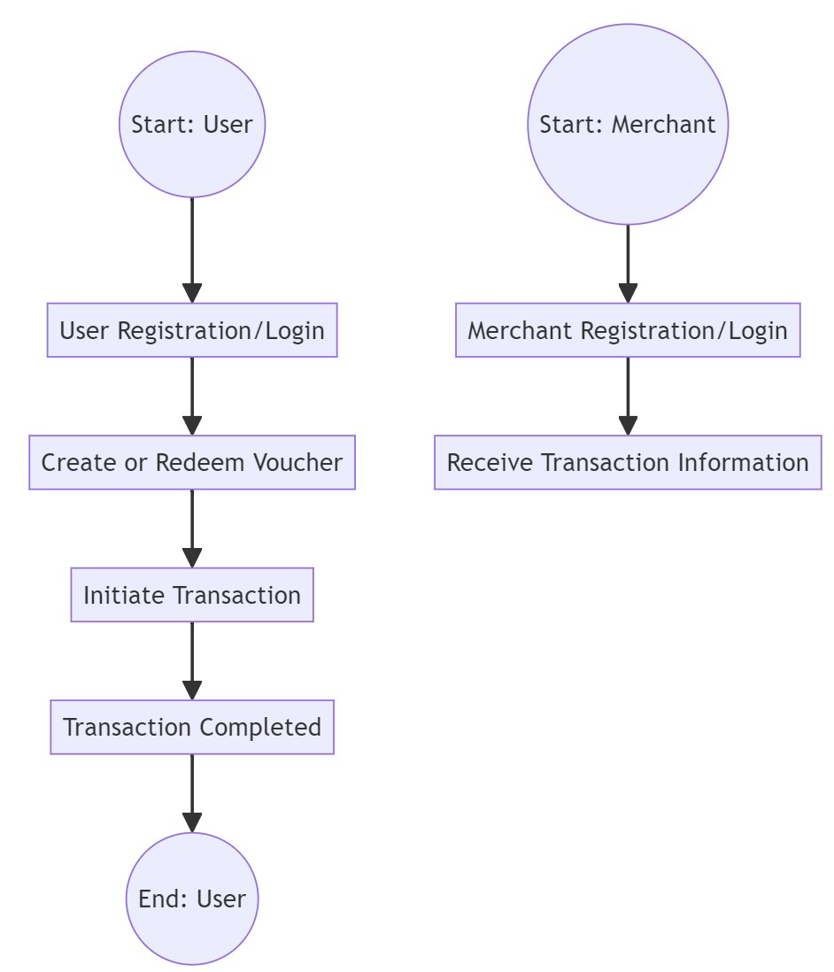

**Figure 7.1.1 Digipay - DFD**

**7.2 Development Environment Setup**

Dev environment setup:

1. Download backend and frontend GitHub repositories in different folders.

2. Download Firefox developer edition. Enable an extension for CORS.

2. Run docker desktop application.

3. Run windows PowerShell in admin rights -> Navigate to the backend root folder ->Type the command Docker compose up

4. Open the index.html page from frontend in the Firefox browser and begin logging in.

**7.3 Data Models and Database Design**

ER Diagrams guided the structuring of data entities, and MongoDB was selected for its flexibility. The database schema accommodates user, course, and lesson data, optimized for efficiency.

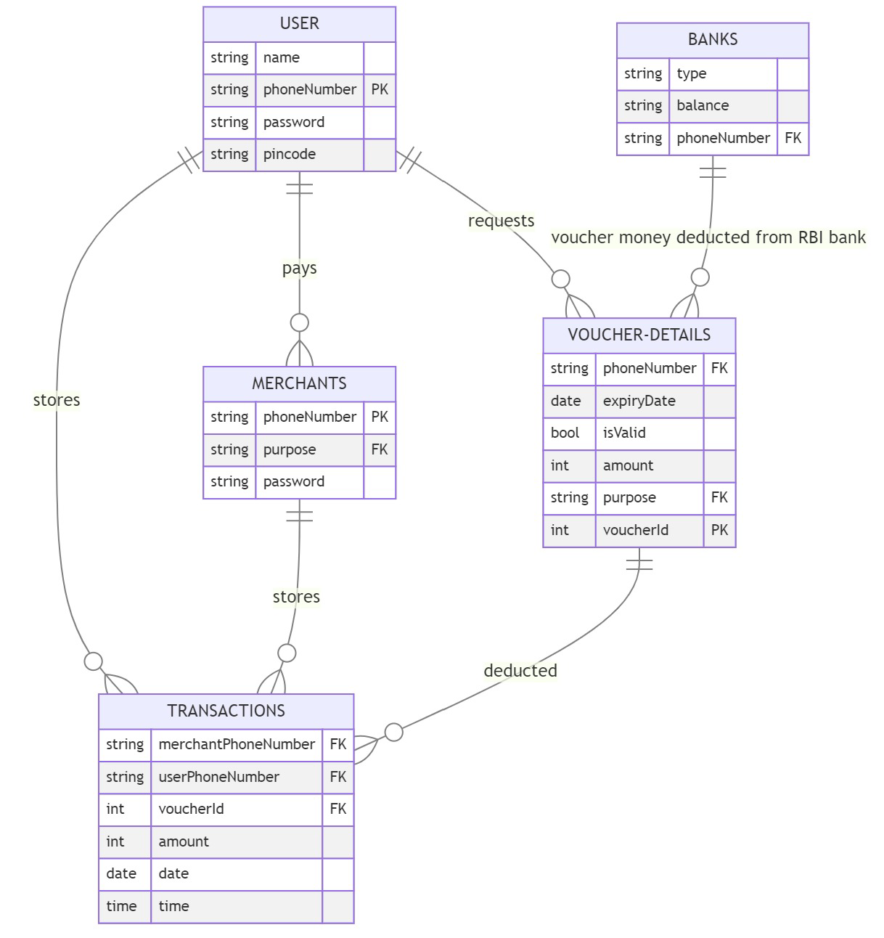

**Figure 7.3.1 Digipay – (ER Diagram)**

**CHAPTER 8**

**RESULTS AND EVALUATION**

**8.1 Presentation of Project Outcomes**

**Figure 8.1.1 Project Outcomes**

**8.2 Interpretation of Results**

Interpreting the results of a digital wallet integrated with e-RUPI involves analyzing transaction volumes, user engagement metrics, conversion rates, customer satisfaction levels, security and compliance measures, financial performance indicators, market share comparisons, operational efficiency data, strategic insights, and continuous improvement feedback. By assessing these aspects comprehensively, one can gain valuable insights into the adoption, effectiveness, impact, and areas for optimization of the integration.

**8.3 Limitations:**

• PCI DSS Compliance: To make a digital wallet system, PCI DSS compliance is required.

• e-Rupi API unavailable- We assumed and simulated the e-Rupi API due to it not being available publically.

• Limited Acceptance: The acceptance of e-RUPI as a payment method may vary among merchants and service providers, leading to limitations in the availability of e-RUPI-enabled transactions.

• Dependency on Connectivity: The functionality of the digital wallet and e-RUPI integration relies on stable internet connectivity, which may be a limitation in areas with poor network coverage or during network disruptions.

• User Adoption Challenges: Users may face challenges in understanding and adopting e-RUPI payments within the digital wallet, especially if they are unfamiliar with digital payment methods or have concerns about security and privacy.

• Transaction Limits: e-RUPI transactions may have predefined limits imposed by regulatory authorities or e-RUPI providers, limiting the amount and frequency of transactions that can be conducted through the digital wallet

**8.4 The Future Scope of the Project:**

1. Enhanced Features: Continuously enhance the digital wallet with new features and functionalities such as loyalty programs, rewards, personalized offers, budgeting tools, investment options, and financial management features to cater to evolving user needs and preferences.
2. Global Expansion: Explore opportunities for global expansion by partnering with international e-RUPI providers, financial institutions, merchants, and service providers to enable cross-border transactions and reach a wider audience.
3. Blockchain Integration: Explore integrating blockchain technology into the digital wallet for enhanced security, transparency, and decentralization of transactions, enabling users to securely manage digital assets and conduct peer-to-peer transactions.
4. Artificial Intelligence (AI) Integration: Leverage AI algorithms and machine learning models to personalize user experiences, offer predictive insights, detect anomalies, automate fraud detection, and enhance decision-making capabilities within the digital wallet.
5. IoT and Wearables Integration: Explore integrating the digital wallet with Internet of Things (IoT) devices and wearables to enable seamless payments, authentication, and access control, transforming everyday objects into payment-enabled devices.

**CHAPTER 9**

**CONCLUSION**

Digipay embodies a transformative journey, bridging E-Rupi with ecosystem. While navigating limitations, its commitment to enriching global payment system and well-being remains steadfast. As a dynamic platform, Digipay’s future lies in adaptive growth, technological evolution, and a lasting impact on individuals worldwide.

**References**

[1] <https://www.npci.org.in/what-we-do/e-rupi/product-overview>

[2] <https://www.npci.org.in/what-we-do/upi/product-statistics>

**APPENDICES**

**Frontend GitHub Link: -** [**https://github.com/ar-zoop/Digipay_college_frontend**](https://github.com/ar-zoop/Digipay_college_frontend)

**Backend GitHub Link:-** [**https://github.com/ar-zoop/Digipay_college_backend**](https://github.com/ar-zoop/Digipay_college_backend)